H.T No
Regulations:
A22

Sreenidhi Institute of Science and Technology
(An Autonomous Institution)
Code No: 9A201 Date: 30-Aug-2023 (FN)

B.Tech I-Year II- Semester External Examination, Aug/Sept-2023 (Regular)
ELECTRICAL CIRCUITS AND NETWORKS-I (EEE)

Time: 3 Hours Max.Marks:60

Note: a) No additional answer sheets will be provided.
b) All sub-parts of a question must be answered at one place only, otherwise it will not be valued.
c) Missing data can be assumed suitably.
Bloom's Cognitive Levels of Learning (BCLL)

Remember | L1 | Apply | L3 | Evaluate | L5
Understand | L2 | Analyze | L4 | Create | L6

Part - A Max.Marks: 6x2=12

Answer all QUESTIONS, EACH QUESTION CARRIES 2 MARKS.

 |  | BCLL | CO(s) | Marks
1 | Write the volt-ampere relations of R, L, C parameters. | L2 | CO1 | [2M]
2 | What is duality? What are dual quantities? | L1 | CO2 | [2M]
3 | Define reluctance and magnetic flux. | L1 | CO3 | [2M]
4 | Draw the impedance triangle of series R-L and R-C circuits. | L2 | CO4 | [2M]
5 | Define Resonance? | L1 | CO5 | [2M]
6 | State the maximum power transfer theorem. | L1 | CO6 | [2M]

Part – B Max.Marks: 6x8=48
ANSWER ALL QUESTIONS. EACH QUESTION CARRIES 8 MARKS.

 |  |  | BCLL | CO(s) | Marks
7. | a) | Obtain the equivalent resistance R_{ab} in the circuit shown in figure below.  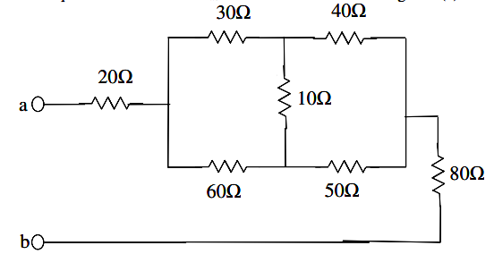 | L2 | CO1 | [8M]
 |  | OR
 | b) | Determine the current flowing through 3Ω resistor using nodal analysis method. | L2 | CO1 | [8M]
8. | a) | For the graph shown below, select a tree and obtain tie-set, cut-set matrices.  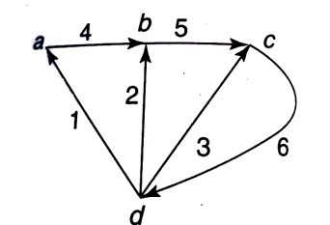 | L2 | CO2 | [8M]
 |  | OR
 | b) | Explain the following terms with reference to network topology with an example. i) Twig ii) Link iii) Oriented graph iv) Incident matrix | L2 | CO2 | [8M]
9. | a) | Derive the relation between self-inductances L₁ and L₂ and mutual inductance M of two coupled coils. | L2 | CO3 | [8M]
 |  | OR
 | b) | Two coils with self-inductances L₁ and L₂ Hendry’s are connected in series aiding and net inductance is found to be 6H and in series opposition (differential) the net inductance is found to be 2H. If the Co-efficient of coupling between two coils is 0.5, Calculate self and mutual inductances. | L4 | CO3 | [8M]
10. | a) | Determine the rms value of the current waveform shown below.  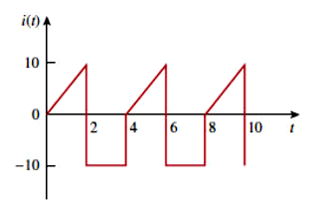 | L2 | CO4 | [8M]
 |  | OR
 | b) | A resistance of 20Ω, an inductance of 0.2H, and a capacitance of 100μF are connected in series across 230V, 50Hz mains. Determine  - Impedance  - Current  - Voltage across R, L and C  - Active and apparent power  v. Power factor | L4 | CO4 | [8M]
11. | a) | Draw the locus diagram of series R-L Circuit with R variable and explain. | L2 | CO5 | [8M]
 |  | OR
 | b) | A Series R-L-C Circuit is resonant at 1 megacycles/sec. Its bandwidth is 5000 cycles per second and input impedance at resonance is 50Ω.  Find R, L and C. | L4 | CO5 | [8M]
12. | a) | Using super position theorem, find the current in 3Ω in the circuit shown  below  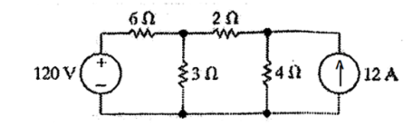 | L4 | CO6 | [8M]
 |  | OR
 | b) | Use Thevenin’s theorem to find the current through 5Ω resistor shown in figure below.  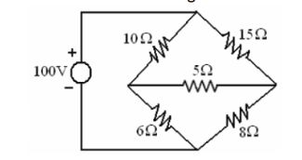 | L4 | CO6 | [8M]

-- 00 -- 00 –

